SV Amplifier
SV Accelerator Strike Team:
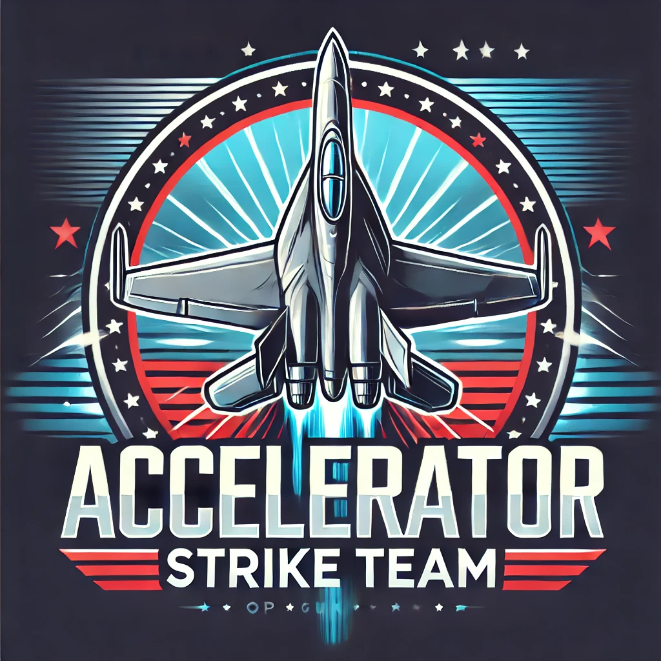
Table of Contents | Quick links
SVA Strategy & Product Planning
1. WHY - Get clear on strategic value & goals for SV & Sequoia
2. WHAT - Define scope, limitations and product approach
3. HOW -
4. WHO -
5. WHEN -
Next Steps
Questions | Confirmations:

SVA Strategy & Product Planning

WHY - Get clear on strategic value & goals for SV & Sequoia
  - Strategic Value:
    - SV -
      - Opp to invest in 20 companies before July 2026
      - Key Benefit: Improve financial returns (De-risk early stage, Increase ownership)
      - Reputational - SV Known
    - Sequoia -
      - Formal channel for attracting, vetting and engaging emerging vendors
      - Position Sequoia as the leader in client innovation
  - Define Success Metrics
    - SV Outcomes Goal:
      - Reputational amplification - SV known as the top VC
        - Metrics:
      - Formalized Ecosystem - ## signed on for XYZ with clear defined role (touchpoints)
      - Sourcing Metrics - % / # of companies identified and engaged
      - # of conversions to full SV investment – 3-5 of 20 in PY8 targeted for full SV investment.
      - Sequoia Rev / ARR post investment
    - Sequoia -
      - Identify & engage top vendors for client offerings
      - Educate growth & client service teams on trends / innovations

  - TImeline Approach:
    - Needs: Publicly announce formal accelerator program ASAP to gain traction with both innovators, especially those building in AI (Sourcing), and potential Fund IV LPs.
    - Considerations:
      - Transform is a great platform for launching SVA.
      - Need time to get buy in from partners
      - Need to align program definition and activations with engagement opportunities through EOY.
      - Efficiency gains from running grouped cohorts through structure programming.

Rolling applications, hybrid w/ jump start
Demo Day 2-3x a year, rolling programming aligned to product-market,

WHAT - Define scope, limitations and product approach
  - Terms - costs, fees, asks for participants
  - $50k investment and $100k of granted equity warrants with rights for an additional $500k of investment in Seed/A (is what we discussed and I think is a good placeholder now. So Fund 3 would reserve $1m of investment ($50k times 20)
    - CT edit - $150k of total equity broken into a $50k cash investment and $100k grant. SemperVirens has pro-rata rights of $500k into the next round of funding.
  - Corporate funds for Fund IV

  - Yes / No’s for product scope
    - Define Boundaries for how much of the ecosystem we unlock for the accelerator terms (i.e. $50k++) vs. investing directly and unleashing the ecosystem for full investments.
    - Capacity & resource considerations for product activations

HOW -
  - Operational Goals:
    - 10 participants in 2025, 10 in 2026
    - 100 applications for 2025, 100+ applications for 2026
  - Announcements:
    - .
  - Application Materials:
    - SV Accelerator Application Materials
    - Reference PTP, Sequoia RFI
  - Application Process:
    - Submissions via branded form (Typeform?)
    - Integrated across centralized database

    - CEO Rubric - Raquel/Colin
  - Tech Tools
    - AI (notes, feedback, scorecards, etc.)

  - Participant Selections | Due Diligence :
    - Define Diligence Group
      - Who is on the screening committee?
      - Is there a target "sector" allocation we want across the 10 companies?
    - Application scorecard Materials:
SV Accelerator Application Selections Scorecard
      - What insights / data SV wants to gain from program participation
        - Application process - 5-7 data points that will give us triggers - defined
        - Selections Committee what do we want them score the companies on… | Colin & Raquel to own
        - Councils & Platform team fill out CEO Rubrik | Raquel
    - Selection:
      - Round 1: Internal team whittles down to 10-20 companies
        - Potentially request Certificate of Standing
      - Round 2: Partners help choose 4-6 finalists, we choose 4 and waitlist 2
        - Need a Certificate of Standing, If we are taking equity, we will need to include
        - Raquel has short diligence list/usual investment asks
          - Make sure your company is set up correctly
          - IP assignments, etc.

  - Program Specifications & Experience:
    - Gathering feedback at every touch point to advise diligence:
      - SV Accelerator - Target Investment Insights | Feedback Form Materials
    - Productize at high-level. Deploy at solution focused level.

 | Stage 1 Program | Stage 2 Program | Stage 3 | Stage 4
 | Pre-Portfolio | Pre-Seed to Early | Early | Growth | Scale
Productization | New Program | <Transition New Investment SvS program> | <Transition Current G8 for Core Program> | <Transition Current G8 for GOF>
SV Benefit | Sourcing & Diligence | Fund Performance | Fund Performance | Fund Performance
SV Fund | Accelerator (Core Fund) | Core Fund | Core Fund | Growth Opportunity
Success Metric | # of companies invested in from program | ARR | ARR | ARR
Program Focus  Founder Value | Initial GTM Feedback​  Product evolution​ | Product Insights​  Advisory Boards​  Got to market Motion​ | 1:1 Customer Acquisition​  GTM expansion​  Mid-market visibility​ | Enterprise Customer Acquisition​  Large Distribution Access​
Operating Model | 1 to many approach, Minimal 1x1 engagement | High touch, unleash ecosystem | High touch, specialized approach | High touch, specialized approach
Program Offerings | Standard Menu + ‘Electives’ | Custom Success Plan | Custom Success Plan | Custom Success Plan
Strategic Partner  Engagement | Participate in 3 SvS Council Series Demo Days | Innovation Session & 1:1 intro’s | Innovation Session & 1:1 intro’s | Innovation Session & 1:1 intro’s
Industry | Access to SV private industry events & networking | Access & Speaking opps at SV private events | Access & Speaking opps at SV private events | Access & Speaking opps at SV private events
SV Advisor Communities | Race to 5 | 5 Direct Customer Persona Intro’s | Present to Advisors  (venture, exec, insights) | Present to Advisors | Present to Advisors
SV Ecosystem | – At events – | 20 direct customer persona intros (Race to 20) | Targeted introductions | Targeted introductions
PeopleTech | PTP Growth Program | PTP Growth Program + | PTE | PTE
SMEs  (i.e. David Cook, Mary T.) | 2-3 GTM Expert Sessions | Targeted prep-calls ahead of key industry opportunities | Target based on needed | Targeted based on needed
Strategic Insights | Summary of aggregate accelerator feedback | Advisor Task Forces | Advisor Task Forces | Advisor Task Forces
Market Insights | Trends & Insights Reports | Trends & Insights Reports | Trends & Insights Reports | Trends & Insights Reports
Trusted Partner Suite | Access | Access | Access | Access

UPDATE BELOW IN SOURCE DOC: SvS Amplification Program Products

 |  |  |  | Program Participation
SvS Program Products | Program Product Description | Program Product Participant / Partners | Product Type | Stage 1  ($50k++ investment level) | Pre-Seed | Stage 2  Early | Core Fund Investment
Sequoia Innovation Council Series |  | Compliance  Product  Sales  Security  Integrations  Marketing | Innovation Council
HCM / Workforce System Council Series | ADP, Paychex, ServiceNow, Workday | CHRO, Product, Sales, Security, Compliance, Integrations | Innovation Council
Life/Di Carrier Council Series | MetLife, Guardian, Unum | CHRO, Product, Sales, Security, Compliance, Integrations | Innovation Council
Health Plan Council Series | Cigna, Healthworx, Elevance | CHRO, Product, Sales, Security, Compliance, Integrations
Hospital Council Series | UPMC, Northwell, Mayo | CHRO, Clinical, Providers, etc. | Innovation Council
Financial Services Council Series | Fidelity, Morgan Stanley
Broker Council Series | Sequoia, One Digital, WTW or Aon |  | Innovation Council
Venture Capital | 5 Seed stage: Village, BTV, Delfine, (Bread & Butter?), 5 Late Stage: a16z, GC, Upfront? | General Partners, Business Development/Platform | Tech Week/funraising support/GTM additional assistance
Conferences | Transform, HR Tech, ITC, HLTH, JPM, Maybe Money 2020 | Key leaders build connectivity to get tracks and influence | Venture Insights/Industry events
Workforce Council Series | PTP Growth Program | PTP |  | Innovation Council
Enterprise Council Series | PTE |  |  | Innovation Council
GTM Expert Sessions | Targeted meetings with SvS SME's on specific GTM focus areas: i.e. Michele - Marketing Amplification, David Cook - Security & procurement readiness |  | SME Session
SV Partner Engagement |  |  | SME Session
Race to 20 | 20 introductions within target market in the 90 days after launching the SvS |  |  | FALSE | FALSE
Advisor Feedback Session | Feedback session with target advisor group to gain insight into product, go to market strategy and more |  |  |  | FALSE
Happy Hour/Dinner | Co-Host Happy Hour/Dinner with target market attendees, prospects, VC alignment and other strategic connections |  |  |  | FALSE
Speaking Engagement | High-level exposure to SemperVirens ecosystem |  |  | FALSE | FALSE
Strategic Partner Events & Introductions | Introduction to industry leading event and partner connections to elevate portco brand |  |  |  | FALSE
New Partnerships Build | Line of site to New Large Distribution Channels |  |  |  | FALSE
New Community Build | Line of site to New customer market relationships |  |  |  | FALSE
Custom Advisory Boards | Co-build advisory board utilizing SemperVirens ecosystem to align strategic goals to specific persona |  |  |  | FALSE

WHO -
  - SEE: SvS Amplification Program Products above.
  - SV Team
    - Have an SV Partner owner within each category
  - SV Strategic Partners / LPs - dedicated innovation Councils
    - ADP, MetLife, Cigna, Guardian, Paychex, Unum, Sequoia
    - Noting: MAJORITY have major presence in NY/east coast - may need to think about how diversify to have partners in SF
  - SV Advisors
  - PTP
  - Sequoia / Sequoia Innovation Lab

Sullivan | Christina | Client Services
Cloern | Jed | Growth
Gonzalez | Jose | Growth
Mangiola | Mark | Growth
Hansraj | Meghna | Client Services
Ellsworth | Melissa | Growth & Operations
Floriani | Michele | Marketing
Knapp | Molly | FinServ & Growth
Rajanna | Vivek | Engineering
Cook | David | Security

WHEN -
  - Announce at Transform:
    - SV Summit
    - LP Conference
    - Transform Main Stage – Innovation Ally
  - Applications:
    - Application window:
    - .

  - Program V.1:
    - …

Next Steps
Immediate:
- SEE: Asana Project Plan

Immediate Next Steps:
- SV Platform team to map remaining Transform build needs and identify areas for support.
- Erin, Emily, Dalton set to meet M, W, F next few weeks to activate across teams and define cross team resourcing and R&Rs. – scheduled
  - Emily
  - Shannon & Jackie - will get high-benefit from amplifier | Marketing
  - Sales enablement - get the word out across sequoia | engaging BCs in the program experience. Recruit vendors to apply to the program.
  - Sales development - find good distribution fits for bundle programs. |
  - Chris - Senior Partnership Manager getting people into the bundle flow| help us build the standard educational / sales materials for program participants (3 slides - problem statement, solution, client profiles / pricing)
- Program productization build out – Erin, Dalton, Arsh prepping initial iteration ahead of Tuesday Analytical. – in-progress
- Definition of program terms & legal coordination – Colin supporting next steps with investment team to define program terms / costs for founders.
  - Richard / Steve for next steps on Legal.
- Strategic Partner Engagement –
  - Robby to add the who’s-who preferences across target strategic LPs to the strategy doc by Tuesday - Done
  - Platform team to draft comms & initial program marketing materials for initial LP outreach – Dalton taking first draft today
- Application Materials –
  - Erin to share recommendation for application assets with Colin, Raquel by Tuesday. - Done
  - Colin & Raquel to give feedback on assets requested to align with data / insights suggested for diligence and initial candidate selections
  - Once confirmed - Greg to own application submission build with Sequoia tech

- Identify who at Sequoia to help with immediate next steps (pre-Transform)
  - Marketing for SV Amplifier - Emily’s team can assist as it helps to push them to SV amplifier
    - Announcement
    - Announcement & Application landing page And/OR Subscribe to receive applications open nominations
    - Landing page on SV website
    - One pager
      - Founder
      - Partnership
      - Advisor

  - SV @ Transform Help
    - Comms
    - Panel Preps
    - Speaker Coordination
    - RSVP list serv
    - Calendar-ing
  - Emily / Team?
    - Landing Page Copy:
      - https://docs.google.com/document/d/10zLeXMohYlEkom-vmM82OivYhBmxGA61LAFFW3TPCJ4/edit?usp=sharing

- Finalize Terms - in progress
  - Investment Team
  - Legal
- Meeting cadence - done
  - Emily, Erin + Dalton - M,W, F weekly 30 min
  - Analytical
- Define exactly who we want involved - in progress
  - Councils?
- Meet with each LP
  - Define MVP, will we ever want to move to paid partnerships?
- Program definition - one pager
- Emily:
  - Value prop - engaging with SV amplifier
  - Sequoia engagement definitions
  - Starting marketing (Jackie, team)
- Colin/Raquel - to share with Erin/Robby
  - What are we not getting from PTP?
  - Shares of companies
- Dalton
  - Partnership comms
- Emily to own applications through Monday
  - Scrub doc

Accelerator Knowledge Capture: See deck

Project Communications

Update Email - Fri, February 28

Hi team -

Happy Friday! To keep us on track with our tight timeline, I’ve consolidated all action items into the SV Accelerator Asana project plan for the MPV launch and immediate post-Transform priorities. Please review the timeline, key milestones, and assigned tasks.

We identified 4 main focus areas over the next 17 days to initiate launch at the SemperVirens Summit - see extended project tracking in Asana.
- Branding + Marketing Collateral (Michele/Erin) | ON TRACK
  - Name + Branding: Michele + team to test name/branding in press release/marketing materials, next phase is internal review with team
  - Communication Deliverables (i.e. landing page, one pagers, slide decks, LinkedIn): Dalton to provide creative briefs to marketing team
- Partnerships (Robby/Erin) | REQUIRES ATTENTION
  - Need to hit send on first round of communications to partners
- Application/Sourcing (Emily/Erin) | ON TRACK
  - Reviewing v.1 of application form today, providing feedback for early next week team review
  - Schedule time with investment team to discuss pipeline opportunities
- Legal (Richard/Steve/Erin) | ON TRACK
  - Richard exploring legal requirements (i.e. Acknowledgement of agreements, consents/privacy, TNS)

Next Steps:
- Erin, Emily + Dalton 30 min scrum today, Friday, Feb 28 - to discuss
  - Partnership communication status (Monday, Tuesday, Wednesday)
    - 3-5 slides prepped to review on Monday for conversations (LPs,
  - Executive check-ins - scheduling
    - Suggesting Thursday, March 6th, Monday, March 10th and Thursday, March 12
  - Project deadlines
  - Review creative briefs
  - Project communications review
  - Review v.1 of application form
    - Emily, Richard, Steve, Erin + option to include more language for application, qualtrics, terms + conditions
  - Emily - process + plan for company recruitment from Sequoia
- Main focus next week is marketing collateral
  - Marketing team testing name/branding in marketing materials
  - Dalton to share creative briefs with marketing team today, Friday, Feb 28
- PTP partnership conversations

Assets:
- Strategy + Project Master Doc
- Strategy + Project Master Slides
- Accelerator Naming Recommendations
- Program Products + Journey Timeline
- Landing Page | Creative Brief
- Partnership Communications
- Application Materials

Let me know if you have any immediate questions or concerns. I will follow up later today with progress

Best,
Dalton

Update Email - Wednesday, March 5

Hi team -

Providing a brief update - please see timeline, key milestones and assigned tasks on the SV Accelerator Asana project plan.

Excited to share a few major updates + learnings:
- Name confirmed: SemperVirens Accelerator, powered by the SemperSystem
  - See Accelerator Naming Recommendations
- Partnerships | 3 confirmed, 3 meetings set and outreach to be sent to all by EOD
  - Confirmed Unum, Sequoia and ADP
  - Gauged level of interest with Great American (interested, but we want to reserve the right to engage with MetLife first)
  - Meetings set with MetLife, Guardian and Paychex for first discussions today
  - Initial meeting with Sequoia team set for March 11th
  - Unum already mentioned carving budget for this in 2026, early indication that there is opportunity to use pilot SVA product as a selling point for partner budget in 2026

Progress Tracking:
- Branding + Marketing Collateral (Michele/Erin) | ON TRACK
  - Name confirmed: SemperVirens Accelerator, powered by the SemperSystem
  - Communication Deliverables (i.e. landing page, one pagers, slide decks, LinkedIn): Dalton to provide creative briefs to marketing team
- Partnerships (Robby/Erin) | ON TRACK
  - 3 confirmed (Unum, Sequoia, ADP)
- Application/Sourcing (Emily/Erin) | ON TRACK
  - v.1 of application form on Qualtrics
  - Time set today with Raquel/Allison to discuss selection process and pipeline opportunities
- Legal (Richard/Steve/Erin) | ON TRACK
  - Richard exploring legal requirements (i.e. Acknowledgement of agreements, consents/privacy, TNS), reviewing together today at 8:30a PT

Next Steps:
- Erin, Emily + Dalton 30 min scrum today, Wed, Mar 5 - to discuss
  - Steve + Richard to join, discuss legal requirements and Sequoia engagement
  - SemperVirens Summit content
  - Sequoia Kick Off (Ecosystem & Innovation Council tab) / Partnership slides (WIP slides are 10 - 19)
  - Advisor outreach - review plan + hit send today
- Partnership conversations in full swing
  - MetLife, Guardian and Paychex meetings today
- Marketing Collateral | Dalton to send
  - Master Slide Deck (WIP) includes:
    - Partnership Overview
    - SemperVirens Summit
    - AGM
  - Landing Page | Creative Brief - sent to marketing at Sequoia for review
  - Application
  - Accelerator Naming Recommendations
- PTP partnership conversations

Assets:
- Strategy + Project Master Doc
- Strategy + Project Master Slides
- Accelerator Naming Recommendations
- Program Products + Journey Timeline
- Landing Page | Creative Brief
- Partnership Communications
- Application Materials

Let me know if you have any immediate questions or concerns. I will follow up later today with progress

Best,
Dalton

Update Email - Thursday, March 6

Hi team -

Providing a brief update - please see timeline, key milestones and assigned tasks on the SV Accelerator Asana project plan.

Progress Tracking:
- Branding + Marketing Collateral (Michele/Erin) | ON TRACK
  - Name confirmed: SemperVirens Accelerator, powered by the SemperSystem
  - Communication Deliverables (i.e. landing page, one pagers, slide decks, LinkedIn): Dalton to provide creative briefs to marketing team
- Partnerships (Robby/Erin) | ON TRACK
  - 3 confirmed (Unum, Sequoia, ADP - need logo approval from ADP)
  - 4 very interested, will work to confirm (Cigna, Guardian, Paychex, MetLife)
  - Robby is scheduled with a couple more today
- Application/Sourcing (Emily/Erin) | ON TRACK
  - v.1 of application form on Qualtrics, v.2 based on Raquel/Allison feedback in the works
  - Raquel + Allison reviewed, made comments to the Application Questions, conceptualized selection process (WIP Selection Process tab), identifying pipeline companies for MVP
- Legal (Richard/Steve/Erin) | ON TRACK
  - Richard exploring legal requirements for application page (i.e. Acknowledgement of agreements, consents/privacy, TNS), need by EOW
  - Richard starting draft contracts

Next Steps:
- Partnership conversations progressing
  - Draft partnership slides (22 - 35), v.2 to review with Robby at 12p PT
- Marketing Collateral | Dalton to send
  - Draft partnership slides
  - Landing Page
  - Application
  - Accelerator Naming Recommendations
- PTP partnership conversations

Assets:
- Strategy + Project Master Doc
- Strategy + Project Master Slides
- Accelerator Naming Recommendations
- Program Products + Journey Timeline
- Landing Page | Creative Brief
- Partnership Communications
- Partnership Master Slides
- Application Materials
- Qualtrics Form

Let me know if you have any immediate questions or concerns. I will follow up later today with progress

Best,
Dalton

Update Email - Wednesday, March 12

Hi team -

Great to see many of you in the Sequoia offices yesterday where we held our first SVA partnership kick off with the Sequoia team members participating in the MVP! Alongside the kick off, we held a series of productive meetings across Sequoia and internal teams driving towards our goal of announcing at SemperVirens Summit and launching applications on April 8th.

Providing a brief update - please see timeline, key milestones and assigned tasks on the SV Accelerator Asana project plan.

Progress Tracking:
- Branding + Marketing Collateral (Michele/Erin) | ON TRACK
  - Name confirmed: SemperVirens Accelerator, powered by the SemperSystem
  - Advisory name confirmed: Accelerator Advisor
  - Communication Deliverables (i.e. landing page, one pagers, slide decks, LinkedIn):
    - Sequoia marketing team working on v.1 of the landing page on SemperVirens website
    - Dalton preparing initial SemperVirens Summit slides to review with Robby/Erin tomorrow
- Partnerships (Robby/Erin) | ON TRACK
  - Officially held our 1st SVA partnership kick off with Sequoia, with lots of excitement following!
  - Good news - everyone is super excited (see updates below)
  - Conversations continuing this week

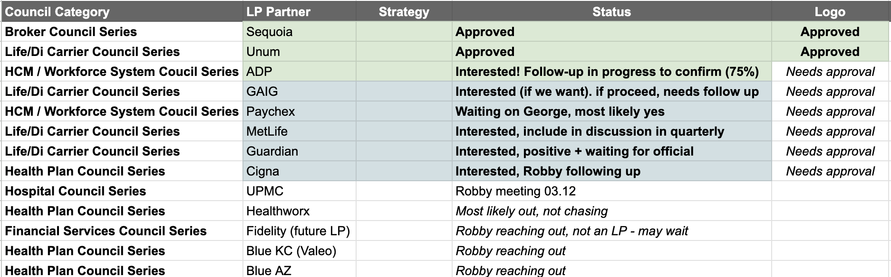

- Announcements ON TRACK
  - Transform - March 17th - 18th:
    - SemperVirens Summit, CEO Summit + AGM slides WIP
    - Standing up landing page with marketing team assistance: V.1 Landing Page + One Pager WIP
    - TBD: QR Code Stickers
  - April 8th:
    - V.2 Landing Page
    - Outreach and Communications Plan WIP
- Application/Sourcing (Emily/Erin) | ON TRACK
  - v.1 of application form on Qualtrics, v.2 based on Raquel/Allison feedback in the works
  - Investment team (Raquel + Allison) identifying pipeline companies for MVP, building process for repeat sourcing and selection

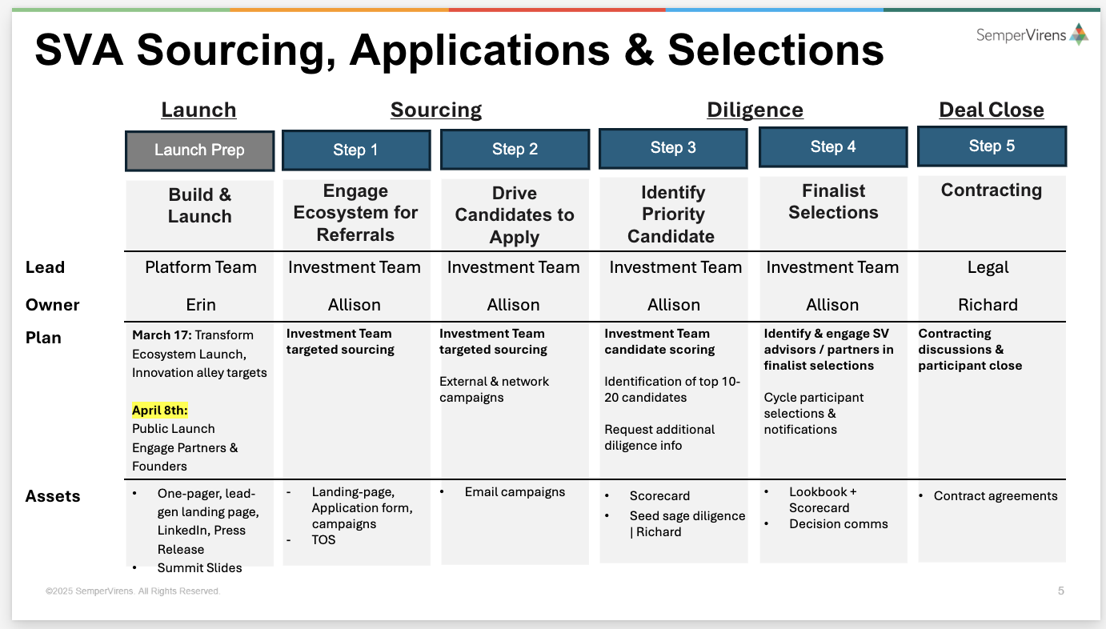

- Legal (Richard/Steve/Erin) | ON TRACK
  - Richard exploring legal requirements for application page (i.e. Acknowledgement of agreements, consents/privacy, TNS), need by EOW
  - Richard starting draft contracts
  - Richard creating specific language for any attorney advisors claiming that we are not offering legal advice, not a law firm, etc.

Next Steps:
- Partnership conversations continuing
  - Final Partnership Preview slides
- Transform Marketing Collateral
  - MUST HAVE:
    - V.1 Landing Page
    - One Pager
    - SemperSummit Slides, CEO Slides, AGM Slides
  - Other:
    - Landing Page
    - Application
    - Accelerator Naming Recommendations
- PTP partnership conversations
- Executive Advisory Outreach
  - Erin to send outreach to our executive advisors to share a preview on Friday ahead of Transform
Assets:
- Strategy + Project Master Doc
- Strategy + Project Master Slides
- Accelerator Naming Recommendations
- Program Products + Journey Timeline
- Landing Page | Creative Brief
- Partnership Communications
- Partnership Master Slides
- Application Materials
- Qualtrics Form

Let me know if you have any immediate questions or concerns.

Best,
Dalton

Update Email - Tuesday, March 25

Hi team -

Hope everyone is rested following an exciting Transform week! Providing a brief SVA update for team visibility.

Congrats to everyone on a well executed announcement of the SemperVirens Accelerator!!! We have received great initial feedback from the ecosystem, (4) initial submissions on the landing page to be notified on April 8th, and strategic partnership buy-in (i.e. MetLife is providing a 50 page document showcasing their internal accelerator program they ran a few years back).

Progress Tracking:
- Program Build (Dalton/Erin/Platform):
  - Initial journey map created here
  - Next Steps: Dalton to define initial tracks for cycle 1 and cycle 2 for review by EOW
- Branding, Marketing + Communication Collateral (Michele/Erin) | ON TRACK
  - ANNOUNCED the SVA to ecosystem partners with great initial feedback, (4) initial submissions to be notified on April 8th, and strategic partnership buy in (i.e. MetLife is providing a 50 page document showcasing their internal accelerator program they ran a few years back).
  - April 8th Application Launch:
    - V.2 Landing Page
    - Outreach and Communications Plan WIP
    - Communication Deliverables (i.e. application/enhanced landing page, LinkedIn posts, partnership communications, etc.):
  - Next Steps: Dalton to schedule time with Michele, Brad + team to enhance current deliverables, create new assets and communication tools - see full plan here and screenshot below

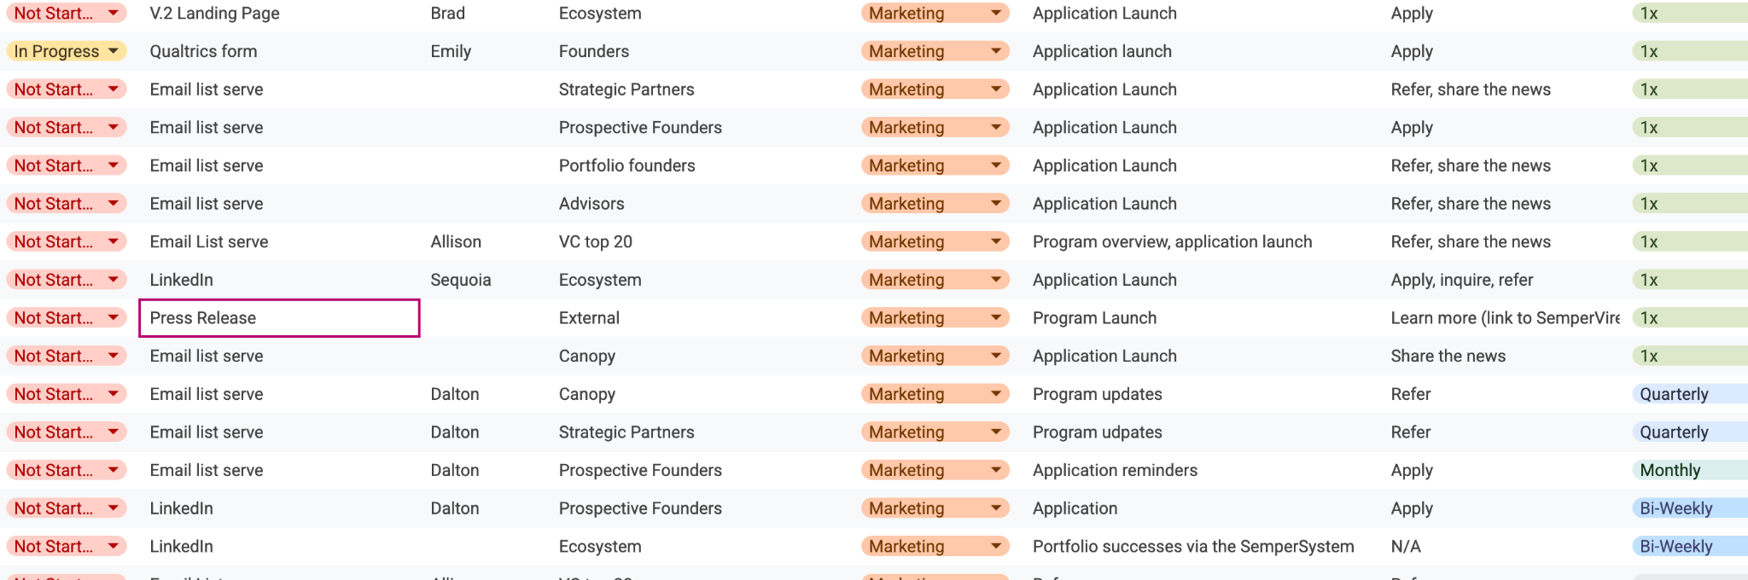

- Partnerships (Robby/Erin) | ON TRACK
  - Initial conversations with partners went well, great feedback and buy in.
  - Next Steps: Partnership commitments, kick offs and announcement communications to be started
  - Innovation Day + Sequoia Kick Off: We are targeting Wednesday, May 21st for SF Bay Area innovation day with Sequoia and select strategic partners. Coordination in motion.
- Advisors (Robby/Erin) | ON TRACK
  - Initial conversations with advisors went well, great feedback and buy in.
  - Next Steps: Advisor commitments, kick offs and announcement communications to be started
- Application/Sourcing (Allison/Erin/Emily) | ON TRACK
  - Investment team (Raquel + Allison) identifying pipeline companies for MVP, building process for repeat sourcing and selection
    - Raquel to build initial pipeline list for investment review
    - Identifying correct tags in affinity to indicate interesting accelerator companies
  - Qualtrix (Emily/Franco) reviewing data points

- Legal (Richard/Steve/Erin) | ON TRACK
  - Richard provided initial legal disclaimers for SVA application

Next Steps:
- Dalton to schedule time with Michele, Brad + Erin, Emily to enhance current deliverables, create new assets and communication tools - see full plan here and screenshot below (scheduling)
- Dalton to schedule time with Bryan, Franco, Erin + Emily to review data points to capture across SVA
- Investment team to review initial pipeline companies suggested for Cycle 1 (to discuss next steps on Mar 25 analytical)
  - Raquel to build initial pipeline list for investment review
  - Identifying correct tags in affinity to indicate interesting accelerator companies
- Partnership commitments, kick offs and announcement communications to be started
- Advisor commitments, kick offs and announcement communications to be started
- Innovation Day + Sequoia kick off coordination in motion
- PTP partnership conversations

Assets:
- Communications Plan
- Press Release
- Program Products + Journey Timeline
- Landing Page | Creative Brief
- Partnership Master Slides
- Application Materials
- Qualtrics Form
- Strategy + Project Master Doc
- Strategy + Project Master Slides

Let me know if you have any immediate questions or concerns.

Best,
Dalton

Update Email - Tuesday, March 25

Hi team -

Marching towards April 8th application launch!

Great progress over the last 24 hours with investment team short-listing and beginning initial outreach to pipeline companies, marketing assets in motion, and cross-canopy data infrastructure discovery.

Progress Tracking:
- Program Build (Dalton/Erin/Platform): ON TRACK
  - Initial journey map created here
  - Next Steps: Dalton to define initial tracks for cycle 1 and cycle 2 for review by EOW
- Branding, Marketing + Communication Collateral (Michele/Erin) | ON TRACK
  - Dalton met with Brad/Jonathan today to discuss enhancing the current SVA landing page and plan to push it public on the SemeprVirens website on April 8th to begin accepting applications.
  - Next touchpoint is Friday, March 28th
  - April 8th Application Launch:
    - V.2 Landing Page
    - Outreach and Communications Plan WIP
      - LinkedIn Social Cards
      - Partnership, advisor, founders and friendly VC communications for launch day to spread the word far and wide
    - One Pager (based off of V.2 Landing Page): Draft to be ready Friday, March 28th for distribution early next week to pipeline companies
    - Press Release: In draft with Erin, ABG/Erin/Dalton meeting with PR Firm on Wednesday, April 2nd to review audience and launch week of April 7th
- Partnerships (Robby/Erin) | ON TRACK
  - Dalton met with Robby and discussed enhancing partnership slides to include next steps, workspace for business unit leader identification and creating ease of engagement for our partners to participate in the upcoming April 8th announcement, May 21st Innovation Day and engage their business unit leaders.
  - Goal is to have Erin send communication on Monday, March 31st - main message:
    - Confirm logo use for press release
    - Skeleton crew join us in SF on May 21st
    - Send us companies
    - Start to think about your business unit leaders and schedule time with SV to discuss
- Innovation Day + Sequoia Kick Off - May 21st: ON TRACK
  - We are confirmed to be hosting the SVA Innovation day on Wednesday, May 21st in SF Bay Area with Sequoia and select strategic partners.
  - Maddie is confirming Skybar at Newmark as venue, Dalton to prepare initial programming and event details in draft
  - Emily has taken next steps to communicate with the Sequoia unit leaders
- Advisors (Robby/Erin) | ON TRACK
  - Outreach to program advisors to invite to May 21st Innovation Day
  - Next Steps: Advisor commitments, kick offs and announcement communications to be started
- Application/Sourcing (Allison/Erin/Emily) | ON TRACK
  - Investment team (Raquel + Allison) identified short-list of pipeline companies to target outreach early next week, investment team tiering their preferences to invite an exclusive 3-4 companies to participate pushing all through the application and using the rest as back ups/early options for cycle 2!
    - Shortlist:
      - Oun Homes
      - Clasp
      - Outro
      - Bordeless AI
      - Basic Capital
      - Livez
      - When Insurance
      - Kept
      - Elayne
      - Anagram
      - Catch Bio
      - Defiant
      - Aligned Marketplace
      - Chronius Health
    - Robby floated the program to the Borderless AI founder receiving great feedback and excitement around participating in the first cycle!!
    - Identifying correct tags in affinity to indicate interesting accelerator companies
- Legal (Richard/Steve/Erin): ON TRACK
  - Richard provided initial legal disclaimers for SVA application
- SVA + Canopy Data Infrastructure (Franco/Emily/Erin)
  - Dalton, Franco and Emily met today to discuss initial data captures for early cycles while building a longer track to meet the following immediate and long-term needs:
    - Market Map Data
    - Company Performance Data
    - Stakeholder Outputs (Trends & Insights, Company Feedback, etc)
    - Performance of SemperSystem + Ability to Deliver
    - Scaling Delivery
  - Identified opportunity to interview strategic partners, advisors, and investors on how they respond to innovation to help inform selection processes - looking to include some form of select interviews at May 21st event.
  - Next touchpoint Friday, March 28th with Franco, Bryan, Emily and Dalton (pending Raquel’s availability)

Next Steps:
- Dalton to define initial tracks for cycle 1 and cycle 2 for review by EOW
- Dalton to prepare partnership communications and enhanced slides for Erin’s send on Monday
- Maddie is confirming Skybar at Newmark as venue, Dalton to prepare initial programming and event details in draft
- Brad/Jonathan designing webpage, one pager
- Investment team tiering their initial pipeline to 3-4 top candidates
- Innovation Day + Sequoia kick off coordination in motion
- Scheduling time with Raquel + Franco to walk through Affinity Market Maps and Market Map Deep Dives that could help inform early programming
- Press Release: In draft with Erin, ABG/Erin/Dalton meeting with PR Firm on Wednesday, April 2nd to review audience and launch week of April 7th
- PTP partnership conversations

Assets:
- Partnership Communications
- Partnership Master Slides
- Outreach and Communications Plan (SVA Launch)
- Press Release
- Program Products + Journey Timeline
- Landing Page | Creative Brief
- Application Materials
- Qualtrics Form
- Strategy + Project Master Doc
- Strategy + Project Master Slides

Let me know if you have any immediate questions or concerns.

Best,
Dalton

Update Email - Monday, March 31

Hi team -

Good morning - happy Monday!

We are on track to be launch ready by April 8th while simultaneously working with partners, internal stakeholders, and cross canopy collaboration for program delivery.

April 8th - Accelerator Launch Readiness:ON TRACK
- Assets:
  - Partnership/Ecosystem Communications
    - Plan: Quote/logo approval by Friday, April 4th, meetings scheduled week of April 7th and April 14th to review next steps
    - Updated Slides
    - Next Steps: Dalton/Erin to review and send today, Monday, March 31, drafting communications for application launch blast across ecosystem
  - Press Release
    - V.1 Draft
    - Next Steps: ABG/Erin/Dalton meeting PR firm on Wednesday, April 2nd
  - One Pager
    - Plan: Wednesday, April 2nd
    - V.1 Draft
    - Next Steps: Provide feedback to Brad/Marketing
  - Application Landing Page
    - Plan: Friday, April 4th
    - To be modeled after One Pager above
    - Next Steps: Finalize once based on One Pager, Dalton to gain Wix access
  - Social Cards for LinkedIn
    - Plan: Friday, April 4th
    - In design with Brad/Marketing
  - Legal (Richard/Steve/Erin):
    - Richard approved initial legal disclaimers for SVA application
    - Richard prepping Term Sheets/Other Necessary Documentation for Cycle 1 negotiations

SemperVirens Accelerator Program Build: ON TRACK
- Program Definition (Dalton/Erin/Platform)
  - Initial journey map created here
  - Next Steps: Dalton + Erin to define initial tracks for cycle 1 and cycle 2 for review
- Innovation Day + Sequoia Kick Off - May 21st (Emily/Dalton/Maddie)
  - We are confirmed to be hosting the SVA Innovation day on Wednesday, May 21st in SF Bay Area with Sequoia and select strategic partners.
  - Next Steps: Maddie is confirming Skybar at Newmark as venue, Dalton to prepare initial programming and event details in draft, Emily has taken next steps to communicate with the Sequoia unit leaders, Erin/Robby to invite strategic partners
- Advisors (Robby/Erin)
  - Outreach to program advisors to invite to May 21st Innovation Day
  - Next Steps: Advisor commitments, kick offs and announcement communications to be started
- Sourcing (Allison/Erin/Emily)
  - Plan: Cycle 1 participant selections targetting April 10th
  - Investment team (Raquel + Allison) identified a short-list of pipeline companies to target outreach early next week, investment team tiering their preferences to invite an exclusive 3-4 companies to participate pushing all through the application and using the rest as back ups/early options for cycle 2!
    - Shortlist:
      - Oun Homes
      - Clasp
      - Outro
      - Bordeless AI
      - Basic Capital
      - Livez
      - When Insurance
      - Kept
      - Elayne
      - Anagram
      - Catch Bio
      - Defiant
      - Aligned Marketplace
      - Chronius Health
    - Robby confirmed to the Borderless AI founder receiving great feedback and excitement around participating in the first cycle!!
    - Identifying correct tags in affinity to indicate interesting accelerator companies
- SVA + Canopy Data Infrastructure (Franco/Emily/Erin)
  - Dalton, Franco and Emily met last week to discuss initial data captures for early cycles while building a longer track to meet the following immediate and long-term needs:
    - Market Map Data
    - Company Performance Data
    - Stakeholder Outputs (Trends & Insights, Company Feedback, etc)
    - Performance of SemperSystem + Ability to Deliver
    - Scaling Delivery
  - Next Steps: Dalton providing affinity market map categorization, scheduling next touchpoint week of March 31

Next Steps:
- Press Release: In draft with Erin, ABG/Erin/Dalton meeting with PR Firm on Wednesday, April 2nd to review audience and launch week of April 7th
- Erin to send partnership communications and enhanced slides
- Dalton/Erin to define initial tracks for cycle 1 and cycle 2 for review
- Innovation Day + Sequoia kick off coordination in motion, Maddie is confirming Skybar at Newmark as venue, Dalton to prepare initial programming and event details in draft
- Erin/Dalton/Emily/Allison/Robby/Raquel to provide feedback needed for one pager, webpage
- Investment team tiering their initial pipeline to 3-4 top candidates
- Scheduling time with Raquel + Franco to walk through Affinity Market Maps and Market Map Deep Dives that could help inform early programming
- PTP partnership conversations

Assets:
- Partnership Communications
- Partnership Master Slides
- Outreach and Communications Plan (SVA Launch)
- Press Release
- One Pager
- Program Products + Journey Timeline
- Landing Page | Creative Brief
- Application Materials
- Qualtrics Form
- Strategy + Project Master Doc
- Strategy + Project Master Slides

Let me know if you have any immediate questions or concerns.

Best,
Dalton

Update Email - Wednesday, April 2

Hi team -

Exciting new developments as we continue to drive toward launch!

We spoke with our media consultant today, and she confirmed what we already knew, the SemperVirens Accelerator will generate serious interest. She is planning to pitch our story to The Information, Axios, and WSJ Pro-Venture Capital!

To ensure maximum visibility and impact,while allowing us to maintain the appeal of the exclusive story for a big splash, we’re recommending the following adjustments to our approach and timeline:

- April 8th - Soft Launch: This will be a targeted announcement to our ecosystem, including LPs, advisors, founders, and SemperVirens Summit attendees requesting referrals and applications. The application will be live, but non-discoverable online and shared through direct communications.

^Dependent on when media picks up the story - we can be flexible as the first cohort will be hand selected and a stream of applications coming in from the ecosystem

- ^Targeting April 15th - Public Launch: A broader push with an exclusive press release, a Transform Live interview, partnership media kits, and coordinated social media campaigns.
This also allows us additional time to confirm our partnership logo/quotes to really drive home the impact we are looking to make with the accelerator!

Please see the updated plan below.

April 8th - Accelerator Launch Readiness: ON TRACK w/ PLAN ADJUSTMENTS*
*timeline adjustments to assets needed have an asterisk - good news, this gives us a bit more time on a few items*
- Assets:
  - Partnership/Ecosystem Communications
    - Plan: Quote/logo approval in motion targeting mid-next week with live meetings week of April 14th to review next steps
    - Updated Slides
    - ADP approved logo usage today! Others to follow shortly.
    - Next Steps: Awaiting logo approval
  - Press Release
    - Plan: Media consultant to encourage news orgs to pick up the story, ^*timeline is media dependent
    - V.2 Draft in motion
    - Next Steps: Erin to provide next pass of edits, media consultant to review and begin shopping to news orgs.
  - One Pager
    - Plan: *Friday, April 4th
    - V.2 Draft
    - Next Steps: Dalton to provide SV team feedback to Brad/Marketing
  - Application Landing Page
    - Plan: Friday, April 4th
    - To be modeled after One Pager above
    - Next Steps: Finalize once based on One Pager
  - Social Cards for LinkedIn
    - Plan: Sequoia marketing to rip an ad unit in canva, Arsh creating social campagins
    - *Monday, April 7th
    - Next Steps: In design with Brad/Marketing
  - Legal (Richard/Steve/Erin):
    - Plan: legal disclaimers for SVA application (done), Term sheets/documentations for negotiations ready by April 8th
    - Next Steps: Richard prepping Term Sheets/Other Necessary Documentation for Cycle 1 negotiations

SemperVirens Accelerator Program Build: ON TRACK
- Program Definition (Dalton/Erin/Platform)
  - SVA 2025 Cycle Plan here with initial track definitions for cycle 1
  - Next Steps: Dalton + Erin to further define track through EOY
- Sourcing (Allison/Erin/Emily)
  - Plan: Cycle 1 participant selections targeting outreach on April 10th
  - Investment team narrowed their list to 6 companies, and will further refine on Friday IC meeting, Erin created ‘sales enablement materials/founder slides’ for investment team (in draft)
    - Shortlist:
      - Oun Homes
      - Clasp
      - Borderless AI
      - Kept or When Insurance
      - Defiant
  - Next Steps: Dalton to provide edits/feedback to outreach assets to be finalized by Monday, April 7th, IC decisions on top 3-4 companies this Friday, Outreach to cycle 1 founders early next week following IC meeting decisions
- Innovation Day + Sequoia Kick Off - May 21st (Emily/Dalton/Maddie)
  - We are confirmed to be hosting the SVA Innovation day on Wednesday, May 21st in SF Bay Area with Sequoia and select strategic partners.
  - Save the dates were sent to our strategic partners
  - Next Steps: Maddie is confirming Skybar at Newmark as venue, Dalton to prepare initial programming and event details, Emily has taken next steps to communicate with the Sequoia unit leaders
- Advisors (Robby/Erin)
  - Outreach to program advisors to invite to May 21st Innovation Day
  - Next Steps: Arsh to reach out to select advisors for participation in the innovation day

- SVA + Canopy Data Infrastructure (Franco/Emily/Erin)
  - Raquel and Franco met today to walk through market map data.
    - Market Map Data
    - Company Performance Data
    - Stakeholder Outputs (Trends & Insights, Company Feedback, etc)
    - Performance of SemperSystem + Ability to Deliver
    - Scaling Delivery
  - Next Steps: Erin/Richard to work on access to our internal tools (affinity, hubspot, etc.) for Franco

Next Steps:
- Press Release: Erin to provide next draft of edits
- Dalton to provide edits/feedback to founder outreach assets to be finalized by Thursday, April 3rd
- IC decisions on top 3-4 companies this Friday
- Outreach to cycle 1 founders Friday, April 4th following IC meeting decisions
- Innovation Day + Sequoia kick off coordination in motion
- Arsh to reach out to select advisors for participation in the innovation day
- Erin/Richard to work on access for Franco to our internal tools
- Richard prepping Term Sheets/Other Necessary Documentation for Cycle 1 negotiations
- PTP partnership conversations

Assets:
- Sales enablement materials/founder slides
- Partnership Communications
- Partnership Master Slides
- Outreach and Communications Plan (SVA Launch)
- Press Release
- Investment Team Sales Enablement Materials
- One Pager
- Program Products + Journey Timeline
- Landing Page | Creative Brief
- Application Materials
- Qualtrics Form
- Strategy + Project Master Doc
- Strategy + Project Master Slides

Let me know if you have any immediate questions or concerns.

Best,
Dalton

Questions | Confirmations:
- Are we assuming that all new investments will have gone through SVA?
- Launch with SV targeted network to ensure highest quality candidates and MVP approach?
- Adjust any partner engagements? LPs? Strategic need to sign anything?

2.24.25 Meetings prep:
- Agenda

Agenda | Discussion Topics | Rough Timing | Recommended Attendees | Notes
SV Accelerator strategic planning update | - PTP next steps  - Bring Greg up to speed on strategy of program  - Learnings, decisions  - Success Metrics  - Timing  - Review proposed timeline and MVP through next cycles | 3:00 - 3:30 | Robby, Greg, Erin  Dalton, Emily
SV Launch Plan Deep Dive | - Review build needs for getting to launch (Transform)  - Transform:  - SV Summit  - LP Conference  - Sourcing for MVP  - Next Steps planning  - Partner engagements  - Sequoia engagement | 3:30 - 4:30 | Robby, Greg, Franco, Dalton, Emily  Richard, Steve  Colin, Raquel (Allison OOO)
Marketing Strategy Discussion | Michele | 4:30 - 5:00 | Michele  Robby, Greg, Erin, Franco, Dalton, Emily
Next Steps |  | Closing & follow-up

- Meeting materials / slides
- Dalton take first spin on order of slides
  - Strategy & Learning | Erin (slide 3 - 4)
  - Success Metrics | Dalton, Emily (Erin)
  - High-level product / program offering grid | Dalton (Erin) (slide 5, incorporate screenshot from above)
  - Resource needs | Emily (slide 7)
  - Initial Program Candidates | Emily –
    - Who we’ve engaged with on Sequoia Innovation Lab
    - SV pipeline
  - High-Level Time | Erin – pull from yesterdays’ slide (slide 14)
  - Detailed program timeline & activities / needs | Dalton (slide 8 -10)
  - Terms & Legal | Dalton
  - PTP next steps | Erin
  - Marketing slides – Michele | Dalton – immediate needs: naming & brand, 1 pagers for sharing
  - Ecosystem Partners | Dalton -
    - Partner list
    - Partner example
  - Transform Launch | Dalton
    - Overview
    - SV Summit Agenda (high-level & link to agenda sheet)
    - LP Conference – high-level agenda from Offsite deck – link to agenda sheet)
  - Build Needs for Programming
    - Evolving current G8 with accelerator model

2.24.25 Meeting Notes:
DATA
- Centralized data across canopy
  - Auto schema across canopy for coherent data
- Globalization of Canopy
  - Sequoia seeing companies in Brazil that Robby should look at
- Should be scrubbed to each canopy company - data for SemperVirens/Sequoia/Transform
- Is there a standardized data model?
  - Actioning perspective
  - IP in formulating a good data model, efficiently
  - Model in the middle
  - Pivot table on good data model is essential
Program Communities:
- Simplify advisors, SMEs, etc into one line/ask
  - i.e. if you don’t sell to employers, you’re not assigned to meet with
Colin/Allison/Raquel to meet with Bryan
- Bryan: Tech/AI to help optimize pipeline/funnel
- Data capture
Terms & Legal
- Need to figure out where the $50k gets invested (i.e. on their last round?)
Name
- Amplify Program “early mid-stage accelerator program”
Next Steps:
- Set up time with Franco(Bryan) for first productization pass
- Plan to Stage 2 (i.e. Robby wants a series A company to come through, etc.)
  - Terms change, not program?

Wednesday, February 26th:
Hi Greg, Michele, Robby and everyone!

Since greenlight on Monday afternoon, Dalton, Emily and I have been parsing out exactly what we anticipate needing between now and Transform to go live with the accelerator MVP and announcements.

Being mindful of resource availability and that most teams are heads down delivering on Transform, we’re seeing a pre-Transform set of must-haves and a larger post-Transform build and foundational data architecture focus.

Here is what we anticipate needing to build, where are activating now and specific resource support needed:

Pre-Transform Required Assets & Build:

Broad announcements & content needs:
- Name/Brand/Logo – Michele | in-progress
- Announcement materials:
  - Landing page copy & content – Dalton building creative brief
  - Landing page with embedded application** – Michele / Greg – we’ll need support to build this on the SV site.
  - Application Form** – Recommend we move forward with MVP within Qualtrics. Emily is activating her team now to support a quick build based on the application questions and materials defined already. We can consider evolving this post-Transform if data architecture changes and we want this information in another system.
  - Application QR code – SV can handle
  - LinkedIn posts and branded content (social cards)
    - Dalton building creative brief and draft copy
    - Portfolio Marketing to help build visual assets
- SV Partners and SV Advisors: Goal is to get initial buy-in and approval to include Logos in Transform announcements. Specifics on engagement requests, roles and commitments to follow post-Transform.
  - Email copy – In draft – Robby prepping to send.
  - Email copy & communications out to Sequoia Council target members – Emily to draft for Sequoia - Goal would be to communicate high-level on the accelerator program to individuals, then post-Transform follow on with details of recommended engagement specifics including roles, commitments, etc.
  - One-pagers– Dalton building creative brief | Portfolio Marketing to help build
  - Slides for preview meetings - Dalton building creative brief | Portfolio Marketing to help build
- SV founder email copy (for MVP program selections)
  - Target friendly – Dalton drafting
  - One- - Dalton building creative brief | Portfolio Marketing to help build
  - Slides for meetings - Dalton building creative brief | Portfolio Marketing to help build
- SV Summit & LP Conference session:
  - Agenda plans (strategy & speakers) – Erin & Robby meeting on this today
  - Speaker outreach email copy – Dalton to draft
  - Content (slides) – Dalton, Erin, & Robby to build framework based on agenda | Portfolio Marketing team help requested to polish

Immediate Post-Transform items:
- Legal – Founder, partner / advisor agreements
- MVP founder selections & confirmations for program participation
- Council assignments
- Program materials
- Formal application selections scorecard & committee
- Additional marketing assets
- Data architecture & foundation | Canopy Build
- Program event planning

With this approach we can get by with actually very limited “back-end” build prior to Transform – See ** on application form, which we recommend going ahead with in Qualtrics, and the website landing page, that seems to be a marketing item.

While we’ll certainly want to do a robust data architecture and technical product build, hoping this allows us to get to launch smartly and with light lift on tech team in the short-term.

We’re going to review this with Franco this afternoon, and welcome any feedback, concerns or considerations.

Thank you!
Erin

